Trade tension cast shadow over flow of Chinese students

When the new semester is around the corner, Chinese students and scholars seeking to study in the U.S. may find it is harder than before to obtain a U.S. visa.

Recently Chinese students and scholars have encountered an increase in visa refusals and duration limits of their visas, China’s Ministry of Education released a warning statement in June, reminding “the need to strength risk assessment before studying abroad.”

In fact, before the trade war escalating with multi-rounds of tariffs, the Trump administration vowed in 2017 to consider restrictions on foreign students from designated countries in the fields of STEM – science, technology, engineering and mathematics.

The international students enrollment in the U.S. showed the first drop since 2007, according to data from Institute of International Education (IIE).

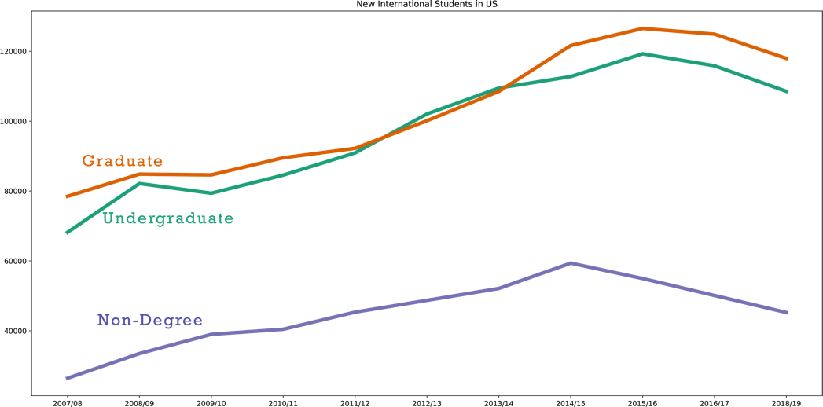

Graphic1: NewIntStudents

Last June, the U.S. Statement made it clear that it would limit the visas for Chinese students studying science and engineering, which are the most popular study fields of Chinese students.

(to add a pie chart)

Graphic2：Fields of Study of Chinese Students in the U.S.

China has been the top place of origin for international students in the U.S. but with the tension increasing and multiple choices for study abroad, the growth of Chinese students going to the U.S. has been declined in recent years.

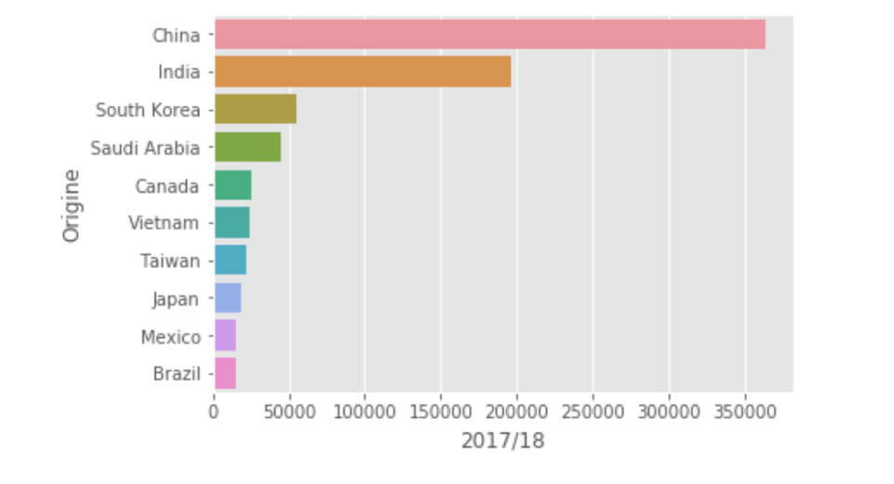

Graphic3: Top 10 places of origine for international students studying in the U.S.

请把图片左边的origine去掉，好像是拼错了吧。。。反正有题目也不需要y轴的标记了

我试着在code里加title = xx, 结果不成功。。。

Graphic4: line chart of chinese students’ growth